**Chapter-1**

**Study of Existing system and system requirements.**

Introduction

Online shopping has dominated the world today; everything from shoes to groceries is available online, so why can't we purchase our medicine online? Older people have difficulty going to medical stores, so online medical shops are a convenient option for them. Furthermore, you won't have to stand in line for the medicines, which will save you time and energy.

Therefore, I developed Online Medical Store Shop, a web application where medicines can be purchased online. The online medicine Store System project replaces the manual process of handling medicine stores with an automated system. As a result, there will be no human errors like entering wrong data about medicines, inventory details, etc.

The admin will handle the entire process from adding the medicine to adding billing information. Each product can be assigned a specific code to avoid errors. Customer details, payments, stock availability, stock details, and supplier details can be managed. Also, it can track the sales activity and also, the growth of the business. Alternatively, users can purchase medicine online.

The application will not only assist the Customers, but also the Shop owner in keeping track of their medicines information.

Objective

The main goal of our system is to create a secure, robust stock market. It keeps track of medicine, sales, and users so that they can be accessed 24 hours a day, seven days a week. By doing so, the customers will be able to place an order from anywhere at any time.

There are two main roles in this application. One is the Admin, who will handle the whole application and has all the privilege of adding medicines to removing them. It can view the order history, the order month list and etc. Another role we have in this application is Customers; they can view the medicine list, and can easily buy them. Also, they can keep the track of their order history.

**Hardware & Software Requirement:**

**Hardware Interfaces**

* Minimum Hardware requirement
* Processor: P4 3.0 GHz
* RAM:1 GB or Higher
* Monitor
* Mouse
* Hard disk: 80 GB

**Software Interfaces**

* Minimum Software requirement
* Spring Boot, JPA
* Logger
* Java (JSP)
* Apache Tomcat Server

All these types of software automatic configure inside operating system after installation it having Java, MYSQL, Apache and operating system base configuration file, it doesn’t need to configure manually.

Application functionality

There are two main users of this application one is the Admin and another one is the Customer.Now, let us see the responsibility.

**1) Admin**

* Admin can Log in/Log out of the system.
* Admin can ADD/VIEW/UPDATE/DELETE Medicine Company.
* Admin can ADD/VIEW/UPDATE/DELETE Medicine detail.
* Admin can ADD/VIEW/UPDATE/DELETE medicine stocks.
* Admin can View/Confirm/Cancel order.
* Admin can manage payments.
* Admin can VIEW all the orders of medicine.
* Admin can manage “My Profile”.
* Can change password.

**2) Customer**

* Can log in/log out of the system.
* Can Manage “My profile”.
* Can search for medicines from a specific category.
* Can upload prescriptions.
* Users can Place/Cancel an order.
* Can make payments online.
* Can change password.

**Note: The login and registrationare also present in the system.**

**Data Flow Diagram(DFD)**

**Level 0:**

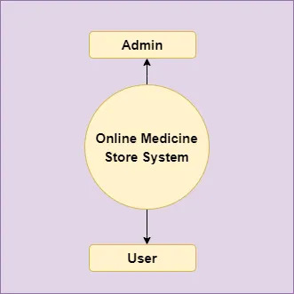

**Level 1**

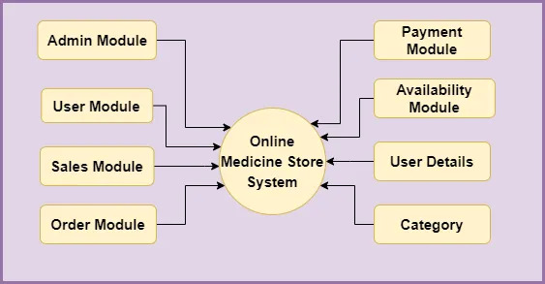

**Level 2-DFD Admin**

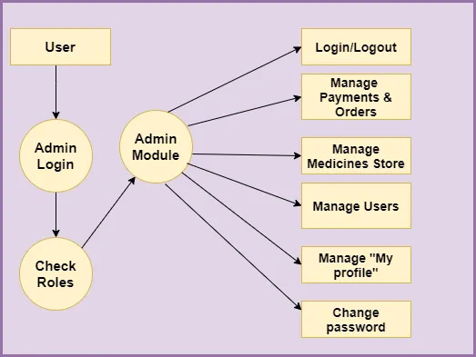

**Level 2 DFD – User**

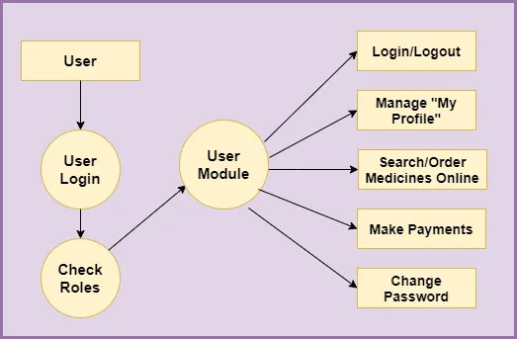

**Feasibility:**

This project will be developed on computer, so first check whether the technology is technically available or not. Now a day’s computer interaction with any job becomes common for any kind of job or work.

And because of increasing usage of Computer, Computer is also available with a variety of hardware. Vendors can fulfill any type of hardware requirement. The whole project is developed by some special tools or by using languages and databases, which are also available in a variety.

Preliminary investigation of a system examines the feasibility of a system that is useful to an organization. It is the first phase of system development.

The main objective of this phase is to identify the current deficiencies in the user’s environment and to determine which existing problem are going to be solve in proposed system and also which new function needs to be added in proposed system.

An important outcome of such preliminary investigation is to determine whether the system that will meet all needed requirements.

Thus, three tests are carried out on the system namely operation, technical and economical.

Any project is beneficial if and only satisfies the organization requirement. For any new system setup, it only meets to be communicated and work the other supporting system.

The new system meets all existing operations since it provides right information at a right time to the right user. A Leigh man can easily operate with the system.

Technical Feasibility examines whether the technology needed is available and if it is available then it feasible to carry out all project activities.

The technical needs of a system include:

* The facility to produce outputs in a given time.
* Ability to process large number of transaction at a particular speed.
* Giving response to users under certain conditions.

The technology needed for our system is mainly:

* Latest version of browsers.
* Any operating system.

These technologies are available which helps to carry out the system efficiently.

Economical feasibility of a system examines whether the finance is available for implementing the new system and whether the money spent is recoverable the satisfaction.

The cost involves is in designing and developing a good investment for the organization.

Thus, hardware requirements used for proposed system are very standard. Moreover, by making use of proposed system to carry out the work speedily will increase and also saves the valuable time of an organization.

In the proposed system the finance is highly required for the installation of the software’s which can also be recovered by implementing a better system.



**System Flow Chart:**

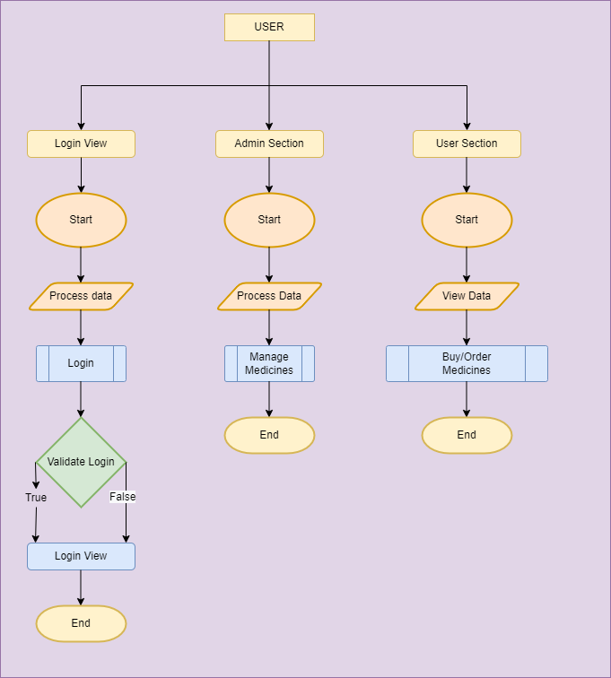

**Data dictionary**

**Data validation:**

Procedures are designed to detect errors in data at a lower level of detail. Data validations have been integrated in the system in almost every area where there is a possibility for the user to commit errors. The system will not recognize invalid data.

Whenever an invalid data is keyed in, the system immediately prompts the user and the user has to again key in the data and the system will accept the data only if the data is correct. Validations have been integrated where necessary.

The system is designed to be a user friendly one. In other words the system has been designed to communicate effectively with the user. The system has been designed with pop up menus.

**Different Type Of validation:**

* Data type validation;
* Range and constraint validation;
* Code and Cross-reference validation; andStructured validation

**Implementation and Testing:**

**Black-Box Testing**:

Black Box Testing, also known as Behavioural Testing, is a software testing method in which the internal structure/ design/ implementation of the item being tested is not known to the tester. These tests can be functional or non-functional, though usually functional.

This can be following way:

* Input interfacing
* Processing
* Output interfacing



This method is named so because the software program, in the eyes of the tester, is like a black box; inside which one cannot see. This method attempts to find errors in the following categories:

* Incorrect or missing functions
* Interface errors
* Errors in data structures or external database access
* Behaviour or performance errors
* Initialization and termination errors.

**White-Box Testing:**

White Box Testing ,also known as Clear Box Testing, Open Box Testing, Glass Box Testing, Transparent Box Testing, Code-Based Testing or Structural Testing is a software testing method in which the internal structure/ design/ implementation of the item being tested is known to the tester.

The tester chooses inputs to exercise paths through the code and determines the appropriate outputs. Programming know-how and the implementation knowledge is essential.

White box testing is testing beyond the user interface and into the nitty-gritty of a system.

This method is named so because the software program, in the eyes of the tester, is like a white/ transparent box; inside which one clearly sees.

**Limitations and Future Application of the Project**

**Futures Enhancement:**

* In future we can expand this project on the cloud.
* In future, we can create a report to analyze the purchase history of medicine like which medicine is sell more or less.
* Further, we can have a role of different sellers of medicine also.

**Limitation :**

In this, we don’t block Customers.

**Screen Snapshot**

**Conclusion**

The Online Medical Shop System provides a single gateway to the Customer and Admin to have a single application where all the activities of the online medicine store are managed properly.

With the online medicine store system, the manual process of handling medicine stores will be replaced with an automated one. As a result, it will be possible to eliminate human errors such as entering incorrect medicine data, inventory details, etc. It is the most convenient and quick shop from where the consumer can quickly get medicines over the internet. Furthermore, it's a secured application where no user can view the purchase history of another user.

This application is designed in such a way that any future modification can be done most easily.